Department of Computer Science and Engineering
No. of Pages | 3
No. of Questions | 4
B
MIDTERM EXAMINATION Summer 2010

CSE 110: Programming Language I
CSE 161: Computer Programming
Total Marks: 40 Time Allowed: 1 Hour and 30 Minutes
- Answer all questions
- Use the answer script for rough work
- Write final answers of Tracing problems on the question paper
- Figure in bracket [] next to each question indicates marks for that question
- At the end of your exam, put the question paper inside the answer script and return both

Name in CAPITAL: _______________________________________________________

ID: __________________________ Course Code: ___________________ Section: ___

Question 1 [10 Points]
Draw the flowchart of a program that takes two numbers from the user, and displays the larger number followed by the words "is larger". If the numbers are equal, print the message "These numbers are equal." [Answer on the answer-script]

Sl | Sample Input | Sample Output
Example 1 | 5, 10 | 10 is larger
Example 2 | 10, 5 | 10 is larger
Example 3 | 7, 7 | These numbers are equal
Example 4 | 12, 11 | 12 is larger

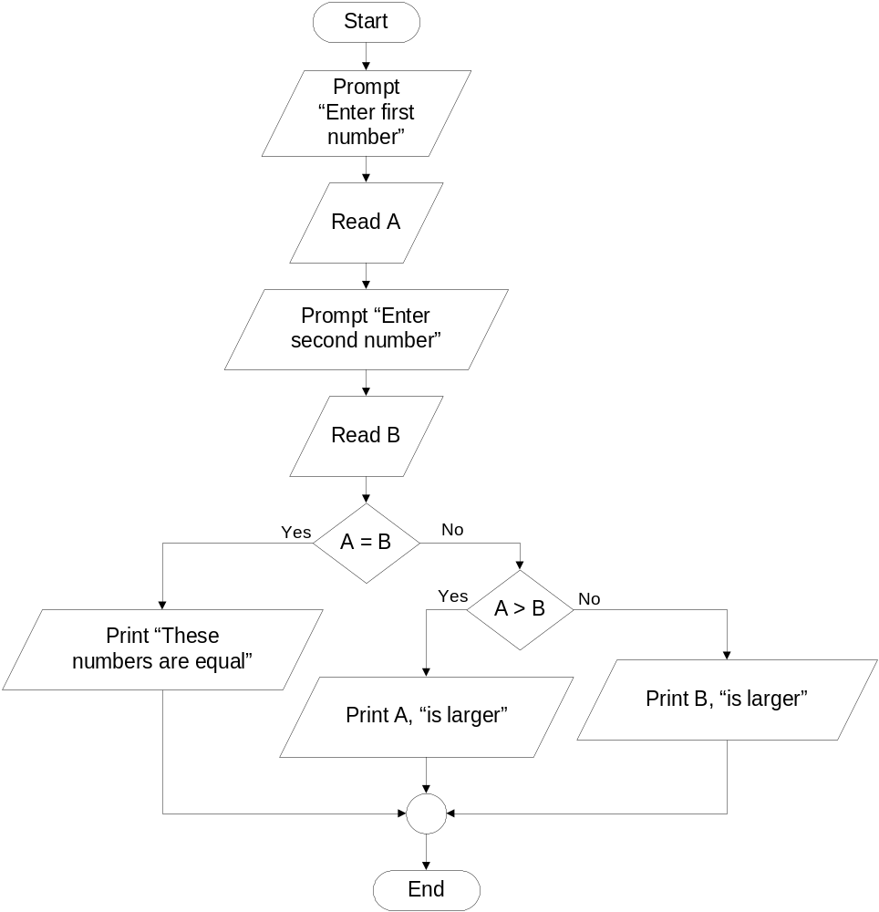

Question 2 [10 Points]
Draw the flowchart of a program that takes 4 numbers from the user, and displays how many numbers were odd and how many numbers were divisible by three. (Use Loop) [Answer on the answer-script]

Sl | Sample Input | Sample Output
Example 1 | 4, 10, 6, 4 | Odd: 0 number(s)  Divisible by three: 1 number(s)
Example 2 | 7, 10, 5, 7 | Odd: 3 number(s)  Divisible by three: 0 number(s)
Example 3 | 3, 5, 10, 6 | Odd: 2 number(s)  Divisible by three: 2 number(s)
Example 4 | 7, 7, 2, 6 | Odd: 2 number(s)  Divisible by three: 1 number(s)

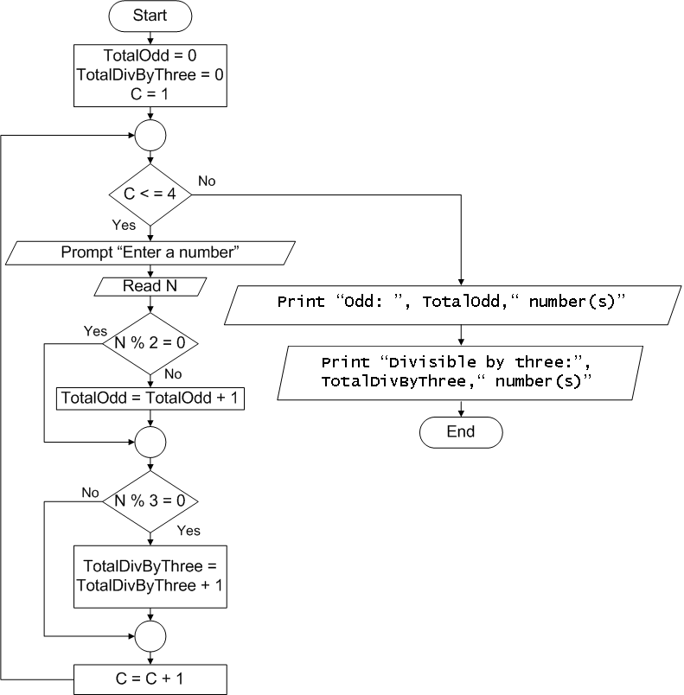

Question 3 [10 Points]
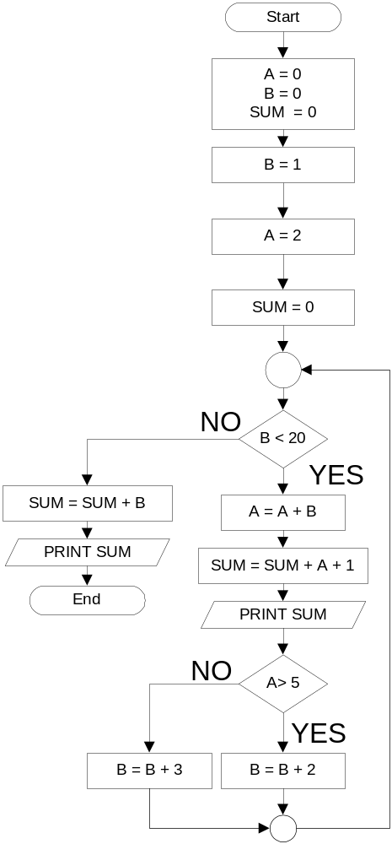
Write the output of the following flowchart:
[Answer on the question paper]
Output
4
12
26
48
80
124
182
256
348
368

Question 4 [10 Points]
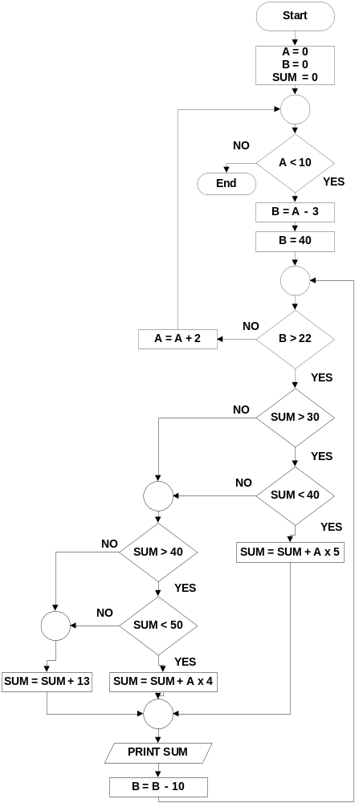
Write the output of the following flowchart:
[Answer on the question paper]
Output
13
26
39
49
65
78
91
104
117
130

